**ASSIGNMENT ON COLLECTION (Assignment-1)**

1. Write a program to calculate the Simple Interest with minimal code using features of

Java 11.

Hint: Use the concept of functional interface and Local variable syntax for lambda

parameters.

**Code:**

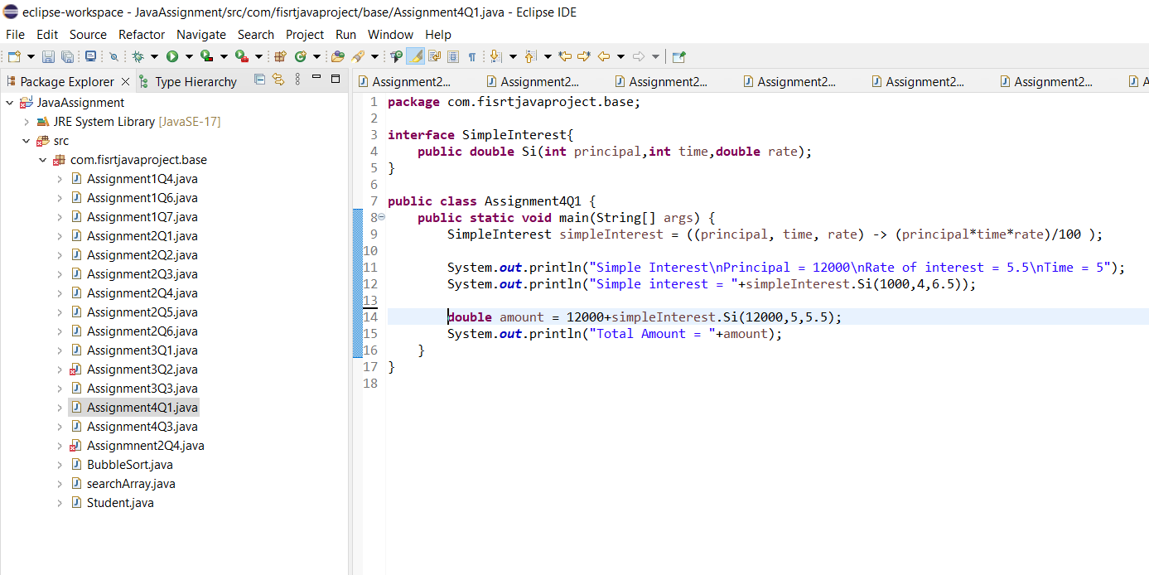

**Output:**

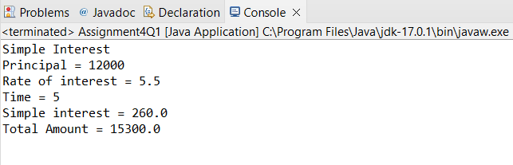

2. Java 11 supports **var** keyword for variable declarations. List the scenarios where **var**

keyword cannot be used for such variable declarations. Give reason in support of

your answer for each scenario.

**Answer:**

3. “A quick brown fox jumps over the lazy dog”. Create an ArrayList from the given

String. Such an ArrayList should include each word from the given sentence. Finally

convert such List to an array using Java 11 methods and print the output.

**Code:**

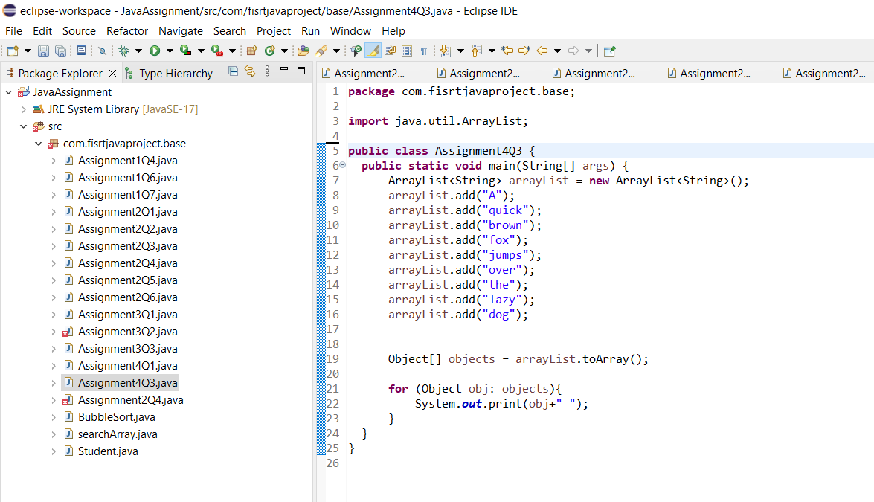

**Output:**

